AI Buddy (SSMS) Extension

Bert O’Neill
Department: | Software Development
Document Title: | SSMS AI Prompt Extension Integration
Author: | Bert O’Neill
Date: | 18-May-2026
Version | 1.0
SharePoint
Document Goals | Provide a user guide, on integrating the SSMS AI Buddy extension within SSMS, and calling Ollama (locally) or NVidia (remotely).

Revision History

Date | Version | Description | Author
18/05/2026 | 1.0 | Initial draft | Bert O’Neill

Contents
1. Revision History 1
1. Introduction 3
1.1. Purpose 3
1.2. Scope 3
2. Prerequisites 3
3. What is SSMS AI Buddy 4
4. Installing SSMS AI Buddy 4
4.1. SSMS Version 19-20 4
4.2. SSMS Version 21+ 6
5. Generate Nvidia API Key 8
6. Configure SSMS AI Properties 10
6.1. Properties Explained 10
7. Selecting the Appropriate (Free Endpoint) Nvidia LLM 12
8. Hosting Ollama & LLM Locally - Setup 15
9. Download LLM and Start Hoster 16
10. Using Editor Context Menu 17
10.1. Joins – non-AI 18
10.2. Joins – AI 19
10.3. Where – AI 20
10.4. Group By\Having – AI 20
10.5. Prompt Dialog – AI 21

Introduction
This document provides details on how your company can integrate AI into your instance of SSMS, allowing developers to send queries to an AI hoster (like NVidia or a local installation of Ollama). And being able to use LLM from DeepSeek but knowing that your prompts will not end up in China!

Purpose
This Document provides a comprehensive overview on how you or your company can integrate AI into Microsoft’s SSMS (19+).

Scope
The scope of this document is to convey the steps involved in connecting to and using (NVidia\Ollama) AI prompts from within SSMS to your hoster.

Prerequisites
- Knowledge of a LLM Hoster (like Nvidia\Ollama)
- Know your Hoster’s URL
- Know your Hoster’s API key (Nvidia only)
- Know the (Nvidia\Ollama) LLM model you wish to use (for e.g. deepseek-coder-v2 or openai/gpt-oss-120b)

What is SSMS AI Buddy
The SSMS AI Extension is an intelligent assistant built directly into SQL Server Management Studio, designed to enhance the productivity of database developers, architects, and DBAs. By leveraging advanced AI models, it enables users to interact with their databases using natural language, generate SQL queries and database objects, explain existing code, and receive recommendations for performance tuning and optimization. The extension provides context-aware assistance based on the active database, schema, and selected SQL, helping users understand complex systems and accelerate development tasks. With support for configurable AI models, memory, prompt templates, and conversational interactions, the SSMS AI Extension transforms SSMS into a powerful AI-driven development environment, reducing repetitive work and enabling faster, smarter database solutions.

Installing SSMS AI Buddy

SSMS Version 19-20
You can download the extension from Microsoft’s Marketplace:
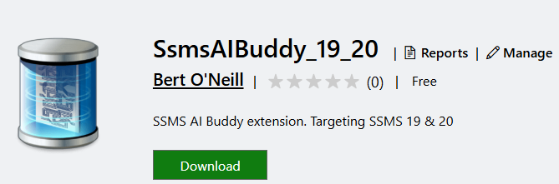
Or search for it inside Visual Studio Extension’s Manager

When you have downloaded the VSIX extension for SSMS 19-20:
Unzip it:
If you have SSMS open, close it first - then copy the unzipped folder into the Extensions folder of your SSMS version – for e.g.
- C:\Program Files (x86)\Microsoft SQL Server Management Studio 19\Common7\IDE\Extensions
- C:\Program Files (x86)\Microsoft SQL Server Management Studio 20\Common7\IDE\Extensions
Restart SSMS, then you should see the extension registered, by the notification in the status-bar after login:

SSMS Version 21+
Download the extension from Microsoft’s Marketplace:
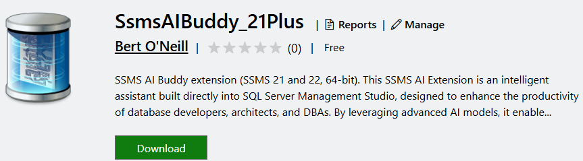
Or search for it inside Visual Studio Extension’s Manager

Double click the SSMS AI Buddy VSIX extension, to initiate the installation process (first, close SSMS if it is open):
You will be prompted to select the SSMS version you wish to install the extension to:
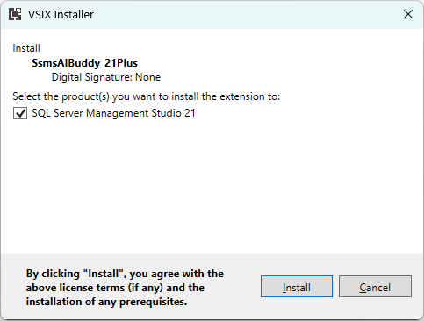
The installation process will begin:
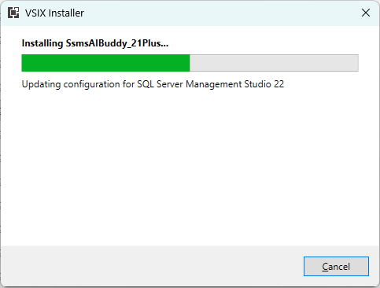
When completed:
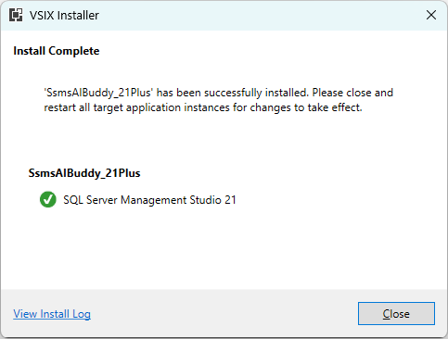
Once installed, restart SSMS and you should see the notification below, in the status-bar:

Generate Nvidia API Key
To use Nvidia’s LLM (which I recommend), you must first generate a free API token. Go to Nvidia’s web site and then click on the Get API Key button:

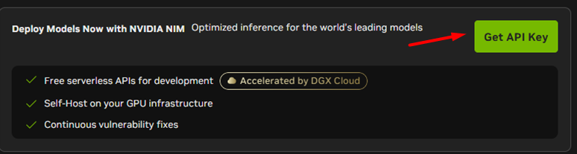

Enter your email address to register:
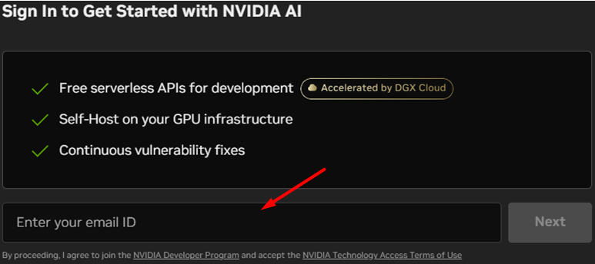

Click on the Generate API button:
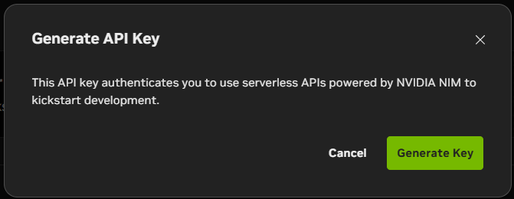

Copy the key and keep it safe, as you will need it when you start to use the extension:
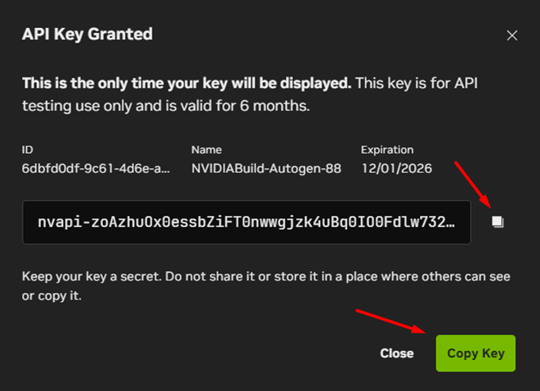

Configure SSMS AI Properties
You can use the more powerful LLM’s hosted by Nvidia (which I recommend) on their servers over the alternative of hosting Ollama yourself locally.

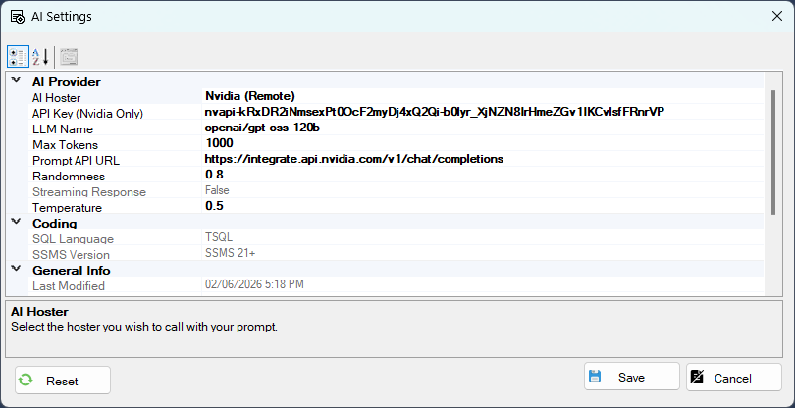

Properties Explained
AI Hoster indicates if you will be prompting Ollama or Nvidia, this is a dropdown from which you can select:
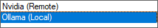
API Key (Nvidia Only) – This property will hold the Nvidia API key that you will have generated, this is only applicable to Nvidia. If you are using Ollama locally, no key is required (but since Nvidia is free, it is more powerful)
LLM Name – The name of your Large Language Model, for e.g. from Nvidia’s site you paste in (see section 7 to browse and select a Nvidia LLM):
- qwen/qwen3-coder-480b-a35b-instruct
- minimaxai/minimax-m2.7
- openai/gpt-oss-120b
Or if you are using Ollama you could use:
- deepseek-r1:1.5b
- qwen2-math:1.5b
- qwen2.5-coder:1.5b
Max Tokens – This indicates the size (words) of the response, 1000 tokens roughly means 750 words.
When prompting through the dialog, keep the important information to the top, because there is a hard cut-off when the token size is reached.
Prompt API URL – This is the API URL to your AI hoster:
Nvidia → https://integrate.api.nvidia.com/v1/chat/completions
Ollama → http://localhost:11434/api/generate
Randomness – Limits the response candidate pool, the higher the value the broader exploration of the response.
Temperature - Reshapes the probability distribution. The lower the value, the more dominant response is selected. A higher value allows less dominant candidates to be returned.
NB: Your properties settings file will be saved to your AppData folder (%AppData%\SsmsAIBuddy\)
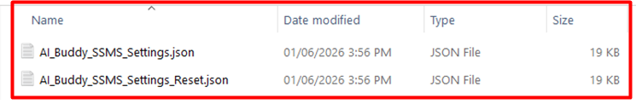
Tip: You can edit the prompts in the file (as the properties dialog is not convenient to do this) and save the file. Also, if you find that you have made a mess of your settings, you can reset, by clicking the reset button in the Property dialog or just delete the file AI_Buddy_SSMS_Settings.json and save a new version.
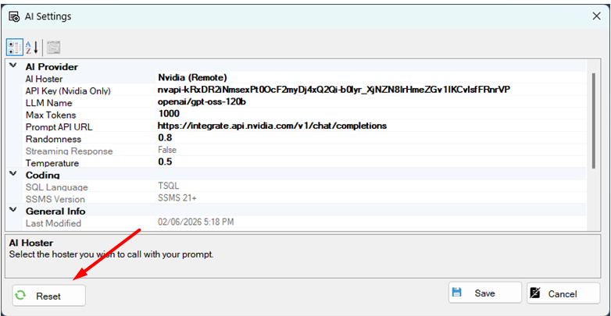

Selecting the Appropriate (Free Endpoint) Nvidia LLM
Navigate to Nvidia’s (models) web site to view the available LLM’s. Enable the Free Endpoint option and click the Apply button.
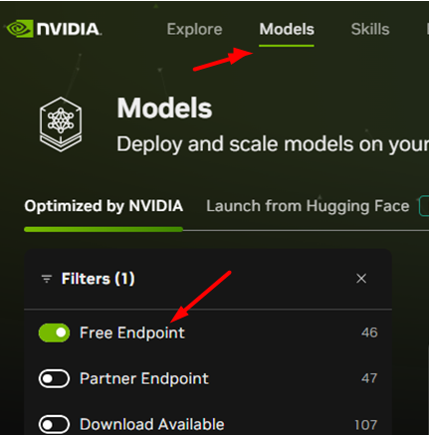
This will list what you can use for free with your API key. You will find that there is a very good selection to choose from – I tended to aim at code generative LLM’s.

For e.g. qwen/qwen3-coder-480b-a35b-instruct
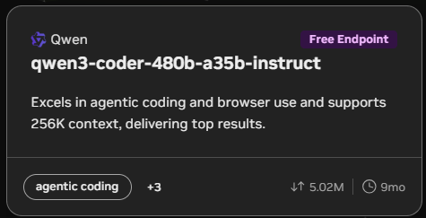
Click into qwen/qwen3-coder-480b-a35b-instruct to view the coding example provided, you just want to copy the full LLM name:
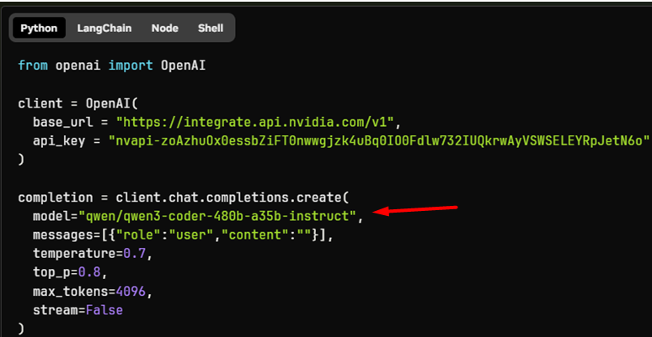
Then paste this LLM along with your API key into the property’s settings:
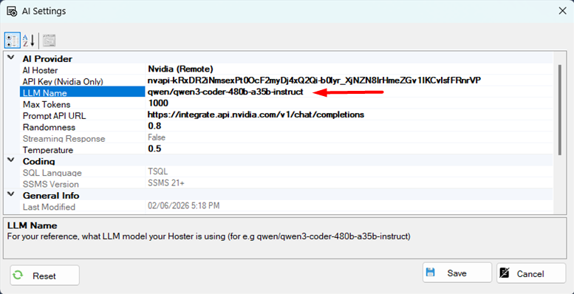
Click Save:
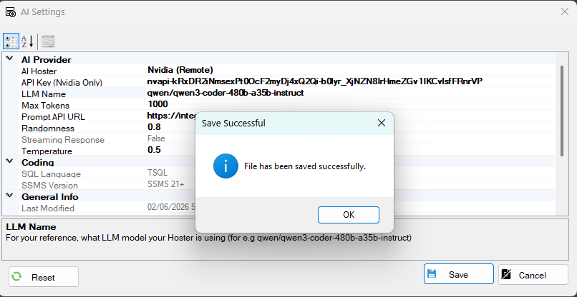

Hosting Ollama & LLM Locally - Setup
If you plan to use the SSMS AI extension with a local instance of Ollama (AI hoster), follow these steps if you have not already installed Ollama locally.
Download and install Ollama using the latest installer for your environment - https://ollama.com/download

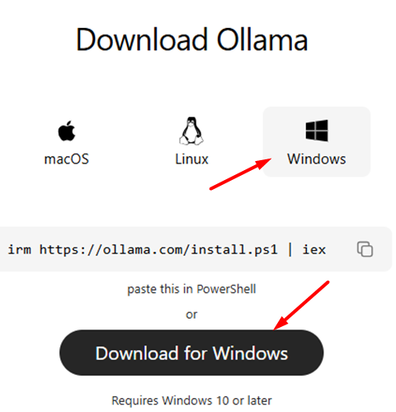

Download LLM and Start Hoster
Select the appropriate LLM - https://ollama.com/search
Or (for e.g.) go directly to the DeepSeek model - https://ollama.com/library/deepseek-v2 and select the appropriate parameter related model. Then click on the copy button and paste this command into a Terminal\Command dialog.
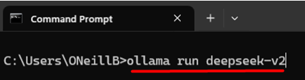

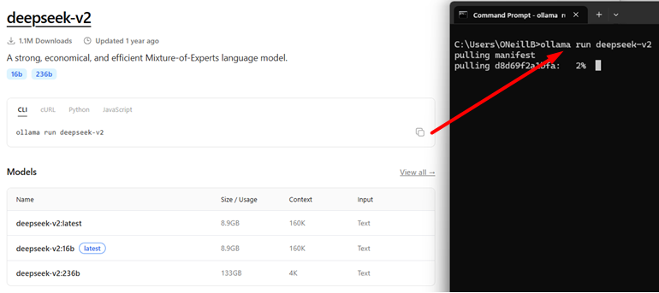

When the model has been downloaded and running, you can verify that Ollama is running from the System Tray:
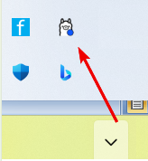

Or from a command prompt run the command ollama list – this will list the available models:
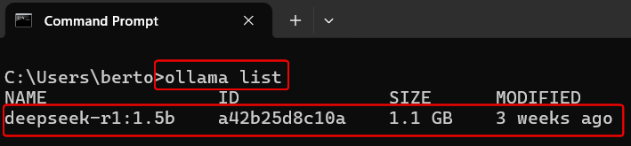

Using Editor Context Menu
Select your database, so that the extension can pick up the schema behind the scenes. Either select from the SMO dropdown:
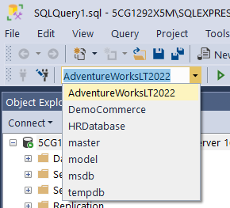
Or by executing a SQL USE statement:
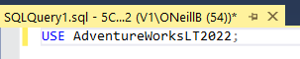
This allows the extension to build up a related schema to the SQL you will want AI to suggest JOINs or a WHERE clause etc.
Enter your SQL statements as normal in the editor, when you want to prompt AI, highlight the SQL statement and right click to bring up the editor context-menu. Then select the menu option SQL AI Buddy, this will allow you to then perform a specific AI prompt against your selected SQL.
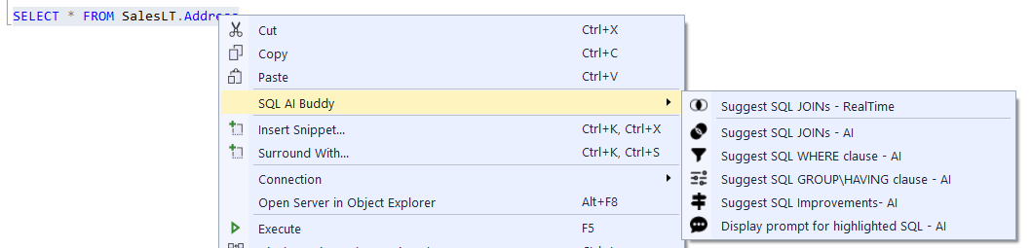

Joins – non-AI
Because you have already selected the database, we can try and perform a non-AI JOIN suggestion – as this is very performant compared to using Ollama locally and even quicker than Nvidia’s remote server’s.
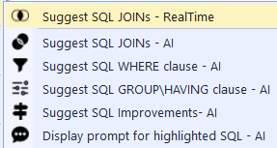
This will quickly result in a number of potential JOIN suggestions based on the table(s) in your query:
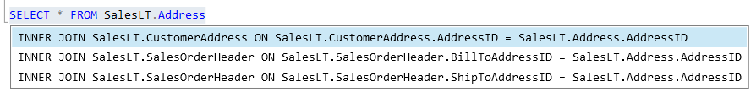
You can traverse the suggestions and double click to select or ESC to close the suggestion pane. The selected suggestion will be appended onto your select query:
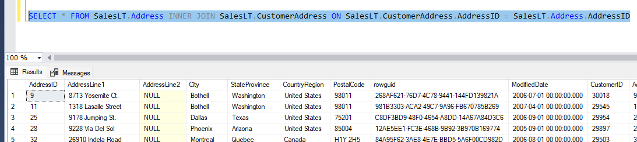

Joins – AI
To prompt AI with your selection, simply highlight the SQL statement and right click the editor to bring up the AI Buddy context-menu, then select Suggest SQL JOINs – AI to send a prompt to Nvidia:
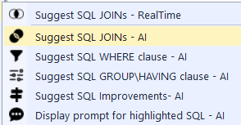
Depending on how busy the remote server is, the response from the prompt may take a few seconds, if the prompt is taking to long – the request will cancel:
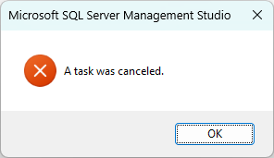
If this happens, just try again, or check that your settings are valid\need to be tweaked for the AI prompt (like changing the LLM used or updating the Temperature or Randomness) – I often use the LLM openai/gpt-oss-120b
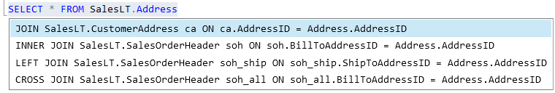

Where – AI

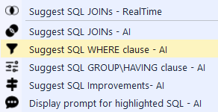

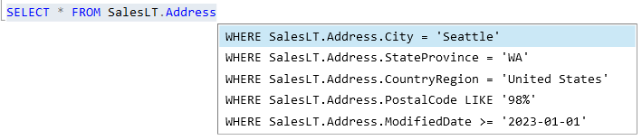

Group By\Having – AI

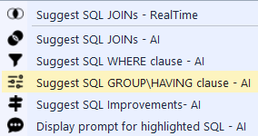

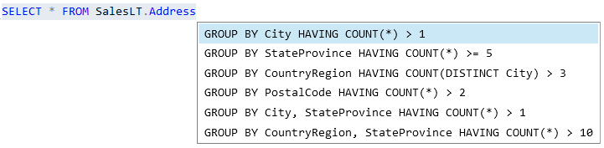
You may just need to tweak the Select statement to fit the Group By\Having suggestion, for e.g.
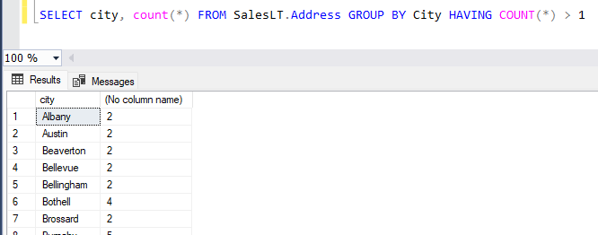

Prompt Dialog – AI
If I have a complex query, I can send that to AI along with my prompt – by selecting the Display Prompt menu option:
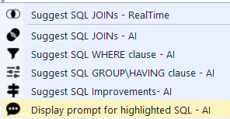
Below I want to ask AI to improve the performance of my complex SQL query:
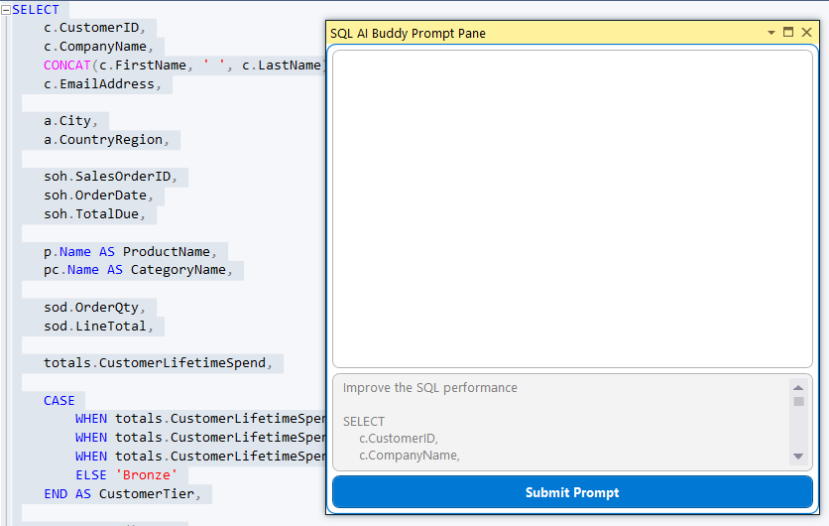
After I click Submit, the prompt will be sent to Nvidia to analyse, and suggestions returned – I can highlight and SQL returned and select Copy to add to the Clipboard and then to my SQL editor:
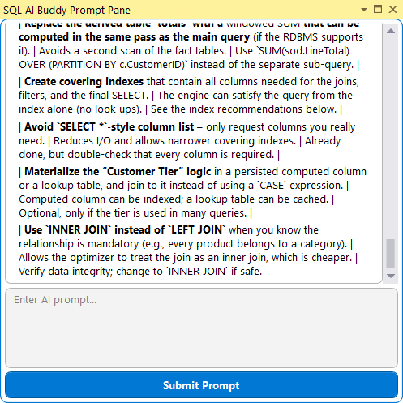
Supplying the SQL statement again and asking a more direct prompt (suggest SQL code)
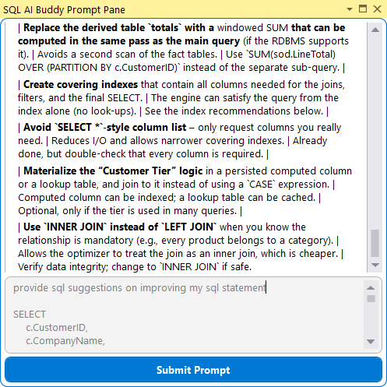
Highlighting the snippet of SQL to copy to the Clipboard:


